PROJECT :

The LIBRARY MANAGEMENT SYSTEM project has book and student class with data members like book no, bookname, authorname. Books record is stored in a binary file. A student can issue book and deposit it within 15 days. Student is allowed to issue only one book. Student Records are stored in binary file. Administrator can add, modify or delete record

CONTENT:

1.Header File Used......
2.Files Generated.....
3.Work Description....
4.Coding......
5.Output Screen....
6.Conclusion....
7.Biblography...

HEADER FILES USED

#include <iostream> For input output functions

#include <fstream>For file handling,cin and cout

#include <cstring>For string handling

#include<cstdlib>For memory allocation and conversion functions

#include "AuthSys.h" For authentication System
FILES GENERATED

Project File
Library management system.cbp
Program File
main.cpp
Header File
Authsys.h
login.h
Object File
Library management system.o
Executable File
Library management system.exe
Data File
bookDatabase.dat
temp.dat
studentDatabase.dat
DESCRIPTION
This project first authenticate the user
and then the user is logged in to the library management system
this system provides following functions which the student can perform in library management system.
1.Main Menu
2. Student Menu
3. Book Menu
4. Issue Book
5. Return Book
6. New Entry
7. Modify Entry
8. Search Entry
9. Delete Entry
10.View Student Details
11.View Book Details
12.Issued status
13.Login
14.Exit.
Code :

MAIN.CPP

#include <iostream>
#include <fstream>
#include <cstring>
#include<cstdlib>
#include "AuthSys.h"

using namespace std;

class Date
{
private:
int dd;
int mm;
int yy;
void rectifyDate()
{
if (dd > 30)
{
dd -= 30;
mm++;
}
if (mm > 12)
{
mm -= 12;
yy++;
}
}
public:
Date()
{
dd = 1;
mm = 1;
yy = 2018;
}
void setDate()
{
cout<<"Enter Date: ";
cin>>dd;
cout<<"Enter Month: ";
cin>>mm;
cout<<"Enter Year: ";
cin>>yy;
}
void setDate(Date temp)
{
dd = temp.dd + 15;
mm = temp.mm;
yy = temp.yy;
rectifyDate();
}
void showDate()
{
cout<<dd<<"/"<<mm<<"/"<<yy;
}
};

class Menu
{
private:
public:
void mainMenu();
void studentMenu();
void bookMenu();
void issueBook();
void returnBook();
};

void Menu :: mainMenu()
{
cout<<"Main Menu"<<endl<<endl;
cout<<"1. Student Menu\n2. Book Menu\n3. Issue Book\n4. Return Book\n";
cout<<"5. Exit"<<endl;
}

void Menu :: studentMenu()
{
cout<<"Student Menu "<<endl<<endl;
cout<<"1. New Entry\n2. Modify Entry\n3. Search Entry\n4. Delete Entry"<<endl;
cout<<"5. View Student Details\n6. Go back to previous menu"<<endl;
}

void Menu :: bookMenu()
{
cout<<" Book Menu "<<endl<<endl;
cout<<"1. New Entry\n2. Modify Entry\n3. Search Entry\n4. Delete Entry"<<endl;
cout<<"5. View all books detail\n6. Go back to previous menu"<<endl;
}
class BookData
{
public:
char title[30];
char author[30];
char publisher[30];
int status;
float price;
int issuedRollNo;
Date issueDate;
Date returnDate;
BookData()
{
status = 0;
issuedRollNo = -9999;
}
};

class StudentData
{
public:
int rollNo;
char name[30];
char address[50];
char branch[5];
int status;
char bookTitle[30];
StudentData()
{
status = 0;
}
};

class Book
{
public:
void inputDetails();
void modifyDetails();
void searchDetails();
void deleteDetails();
void viewAllBookDetail();
};

void Book :: inputDetails()
{
fstream ofp;
ofp.open("bookDatabase.dat", ios :: out | ios :: binary | ios :: app);

if(!ofp)
{
cerr<<"Unable to open file"<<endl;
return;
}

BookData book;
cout<<"Enter book title: ";
cin>>book.title;
cout<<"Enter author's name: ";
cin>>book.author;
cout<<"Enter book publisher: ";
cin>>book.publisher;
cout<<"Enter book price: ";
cin>>book.price;

ofp.write((char*)&book, sizeof(BookData));
ofp.close();
}

void Book :: modifyDetails()
{
fstream file;
file.open("bookDatabase.dat", ios :: binary | ios :: in | ios :: out | ios :: ate);

if (!file)
{
cout<<"Unable to open file"<<endl;
return;
}

file.seekg(0, ios :: beg);

BookData book;
char title[25];

cout<<"Enter book title of the book you want to modify: ";
cin>>title;

while (file.read((char*)&book, sizeof(BookData)))
{
if(strcmp(book.title, title) == 0)
{
int position = (-1)*sizeof(BookData);
file.seekp(position, ios :: cur);

cout<<"Enter new book title: ";
cin>>book.title;
cout<<"Enter new author's name: ";
cin>>book.author;
cout<<"Enter new book publisher: ";
cin>>book.publisher;
cout<<"Enter new book price: ";
cin>>book.price;

cout<<"Record updated";
cin.get();
cin.get();
return;
}
}
cout<<"Book not found!";
cin.get();
cin.get();
return;
}

void Book :: searchDetails()
{
fstream file;
file.open("bookDatabase.dat", ios :: in | ios :: binary);

if (!file)
{
cout<<"Unable to open file!"<<endl;
cin.get();
cin.get();
return;
}

BookData book;
char title[30];

cout<<"Enter book title of the book you want to modify: ";
cin>>title;

while (file.read((char*)&book, sizeof(BookData)))
{
if (strcmp(book.title, title) == 0)
{
cout<<"Book title: "<<book.title<<endl;
cout<<"Book author: "<<book.author<<endl;
cout<<"Book publisher: "<<book.publisher<<endl;
cout<<"Book price: "<<book.price<<endl;
if (book.status == 1)
{
cout<<"Issued status: "<<book.issuedRollNo<<endl;
cout<<"Issued date: ";
book.issueDate.showDate();
cout<<endl<<"Return Date: ";
book.returnDate.showDate();
cout<<endl;
}
else
{
cout<<"Issued status: None"<<endl;
}
cin.get();
cin.get();
return;
}
}
cout<<"Book not found"<<endl;
cin.get();
cin.get();
return;
}

void Book :: deleteDetails()
{
fstream file,temp;
file.open("bookDatabase.dat", ios :: binary | ios :: in);
temp.open("temp.dat", ios :: binary | ios :: out);

char title[25];
BookData book;
int flag = 0;

cout<<"Enter book title to remove: ";
cin>>title;

while (file.read((char*)&book, sizeof(BookData)))
{
if (strcmp(book.title, title) == 0)
{
flag++;
continue;
}

temp.write((char*)&book, sizeof(BookData));
}

file.close();
temp.close();
remove("bookDatabase.dat");
rename("temp.dat", "bookDatabase.dat");

if (flag == 1)
cout<<"Record Deleted"<<endl;
else
cout<<"Record not found"<<endl;
cin.get();
cin.get();
return;
}

void Book :: viewAllBookDetail()
{
fstream file;
file.open("bookDatabase.dat", ios :: binary | ios :: in);

BookData book;
int choice = 1;

while(file.read((char*)&book, sizeof(BookData)) && choice)
{

cout<<"Book title: "<<book.title<<endl;
cout<<"Book author: "<<book.author<<endl;
cout<<"Book publisher: "<<book.publisher<<endl;
cout<<"Book price: "<<book.price<<endl;
if (book.status == 1)
{
cout<<"Issued status: "<<book.issuedRollNo<<endl;
cout<<"Issued date: ";
book.issueDate.showDate();
cout<<endl<<"Return Date: ";
book.returnDate.showDate();
}
else
{
cout<<"Issued status: None"<<endl;
}

cout<<"Press 1 to view the next book else press 0: ";
cin>>choice;
}
cin.get();
cin.get();
return;
}

class Student
{
public:
void inputDetails();
void modifyDetails();
void searchDetails();
void deleteDetails();
void viewAllStudentDetail();
};

void Student :: inputDetails()
{
fstream ofp;
ofp.open("studentDatabase.dat", ios :: out | ios:: app | ios :: binary);

if(!ofp)
{
cerr<<"Unable to open file"<<endl;
return;
}

StudentData student;
cout<<"Enter student's roll no. :";
cin>>student.rollNo;
cout<<"Enter student's name :";
cin>>student.name;
cout<<"Enter student's address :";
cin>>student.address;
cout<<"Enter student's branch :";
cin>>student.branch;

cout<<"Record added to database!";

ofp.write((char*)&student, sizeof(StudentData));
ofp.close();
}

void Student :: modifyDetails()
{
fstream fp;
fp.open("studentDatabase.dat",ios :: binary | ios :: in | ios :: out | ios :: ate);

if (!fp)
{
cerr<<"Unable to open file!"<<endl;
return;
}

fp.seekg(0, ios :: beg);

int target;
cout<<"Enter student's roll no. to modify:";
cin>>target;

StudentData student;

while (fp.read((char*)&student, sizeof(student)))
{
if (target == student.rollNo)
{
int position = (-1) * sizeof(StudentData);
fp.seekp(position, ios :: cur);

cout<<"Enter student's new roll no. :";
cin>>student.rollNo;
cout<<"Enter student's new name :";
cin>>student.name;
cout<<"Enter student's new address :";
cin>>student.address;
cout<<"Enter student's new branch :";
cin>>student.branch;

fp.write((char*)&student, sizeof(StudentData));
fp.close();

cout<<"Record Updated"<<endl;

return;
}
}
cout<<"Roll no. not found!"<<endl;
return;
}

void Student :: searchDetails()
{
fstream ifp;
ifp.open("studentDatabase.dat", ios :: in | ios :: binary);

if (!ifp)
{
cerr<<"Unable to open file!"<<endl;
return;
}

int target;
cout<<"Enter roll no. to search: ";
cin>>target;

StudentData student;

while (ifp.read((char*)&student, sizeof(student)))
{
if (target == student.rollNo)
{
cout<<"Record Found!"<<endl;
cout<<"Student's name: "<<student.name<<endl;
cout<<"Student's roll no. : "<<student.rollNo<<endl;
cout<<"Student's Branch: "<<student.branch<<endl;
cout<<"Student's Address: "<<student.address<<endl;

if (student.status == 1)
{
cout<<"Issued book name is: "<<student.bookTitle<<endl;
}
else
{
cout<<"No book is issued for this roll no."<<endl;
}

cin.get();
cin.get();
return;
}
}

cout<<"Record not found!"<<endl;
return;
}

void Student :: viewAllStudentDetail()
{
fstream ifp;
ifp.open("studentDatabase.dat", ios :: in | ios :: binary);

if (!ifp)
{
cerr<<"Unable to open file!"<<endl;
return;
}

StudentData student;
int choice = 1;

while (ifp.read((char*)&student, sizeof(student)) && choice)
{

cout<<"Student's name: "<<student.name<<endl;
cout<<"Student's roll no. : "<<student.rollNo<<endl;
cout<<"Student's Branch: "<<student.branch<<endl;
cout<<"Student's Address: "<<student.address<<endl<<endl;

if (student.status == 1)
{
cout<<"Issued book name is: "<<student.bookTitle<<endl;
}
else
{
cout<<"No book is issued for this roll no."<<endl;
}

cout<<"To view next student press 1 else press 0: ";
cin>>choice;
}
return;
}

void Student :: deleteDetails()
{
fstream file;
file.open("studentDatabase.dat", ios :: in | ios :: binary);
fstream temp;
temp.open("temp.dat", ios :: out | ios :: binary);

StudentData student;
int target;
int flag = 0;

cout<<"Enter roll no. to delete data: ";
cin>>target;

while (file.read((char*)&student, sizeof(Student)))
{
if (student.rollNo == target)
{
flag++;
continue;
}
temp.write((char*)&student, sizeof(Student));
}

file.close();
temp.close();
remove("studentDatabase.dat");
rename("temp.dat","studentDatabase.dat");

if (flag == 1)
cout<<"Record Deleted"<<endl;
else
cout<<"Roll no. not found"<<endl;

cin.get();
cin.get();

return;
}

void Menu :: issueBook()
{
fstream sp, bp;
sp.open("studentDatabase.dat", ios :: in | ios :: out | ios :: ate | ios :: binary);
bp.open("bookDatabase.dat", ios :: in | ios :: out | ios :: ate | ios :: binary);
bp.seekg(0, ios :: beg);
sp.seekg(0, ios :: beg);

int rollNo, flagS = 0, flagB = 0, position;
char title[30];
StudentData student;
BookData book;

cout<<"Enter Student's roll no to issue book: ";
cin>>rollNo;

while (sp.read((char*)&student, sizeof(StudentData)))
{
if(student.rollNo == rollNo)
{
position = (-1)*sizeof(StudentData);
sp.seekp(position, ios :: cur);
flagS++;
break;
}
}

if (flagS != 1)
{
cout<<"Record not found!"<<endl;
cin.get();
cin.get();
sp.close();
bp.close();
return;
}

cout<<"Enter book title you want to issue: ";
cin>>title;

while (bp.read((char*)&book, sizeof(BookData)))
{
if(strcmp(book.title,title) == 0)
{
position = (-1)*sizeof(BookData);
bp.seekp(position, ios :: cur);
flagB++;
break;
}
}

if (flagB != 1)
{
cout<<"Record not found!"<<endl;
cin.get();
cin.get();
sp.close();
bp.close();
return;
}

if(student.status != 1 && book.status != 1)
{
strcpy(student.bookTitle,title);
student.status = 1;
book.status = 1;
book.issuedRollNo = student.rollNo;
book.issueDate.setDate();
book.returnDate.setDate(book.issueDate);
sp.write((char*)&student, sizeof(StudentData));
bp.write((char*)&book, sizeof(BookData));
sp.close();
bp.close();
}
else
{
if (student.status == 1)
{
cout<<"Student's account is already full!"<<endl;
cin.get();
cin.get();
sp.close();
bp.close();
return;
}
else
{
cout<<"Book is already issued!"<<endl;
cin.get();
cin.get();
sp.close();
bp.close();
return;
}
}
}

void Menu :: returnBook()
{

fstream sp, bp;
sp.open("studentDatabase.dat", ios :: in | ios :: out | ios :: ate | ios :: binary);
bp.open("bookDatabase.dat", ios :: in | ios :: out | ios :: ate | ios :: binary);
bp.seekg(0, ios :: beg);
sp.seekg(0, ios :: beg);

int rollNo, flagS = 0, flagB = 0, position;
char title[30];
StudentData student;
BookData book;

cout<<"Enter Student's roll no to return book: ";
cin>>rollNo;

while (sp.read((char*)&student, sizeof(StudentData)))
{
if(student.rollNo == rollNo)
{
position = (-1)*sizeof(StudentData);
sp.seekp(position, ios :: cur);
flagS++;
break;
}
}

if (flagS != 1)
{
cout<<"Record not found!"<<endl;
cin.get();
cin.get();
sp.close();
bp.close();
return;
}

while (bp.read((char*)&book, sizeof(BookData)))
{
if(strcmp(book.title,student.bookTitle) == 0)
{
position = (-1)*sizeof(BookData);
bp.seekp(position, ios :: cur);
flagB++;
break;
}
}

if (flagB != 1)
{
cout<<"Record not found!"<<endl;
cin.get();
cin.get();
sp.close();
bp.close();
return;
}
if(student.status == 1 && book.status == 1)
{
student.status = 0;
book.status = 0;
book.issuedRollNo = -9999;
sp.write((char*)&student, sizeof(StudentData));
bp.write((char*)&book, sizeof(BookData));
sp.close();
bp.close();
}
else
{
if (student.status == 0)
{
cout<<"Student's account is already full!"<<endl;
cin.get();
cin.get();
sp.close();
bp.close();
return;
}
else
{
cout<<"Book is already issued!"<<endl;
cin.get();
cin.get();
sp.close();
bp.close();
return;
}
}
}

int main()
{
int n;
char opt;

AuthSys A1;

L23: cout<<"\n\n\t\t\tWELCOME TO LIBRARY MANAGEMENT SYSTEM";

cout<<"\n\n\t[1]\tREGISTER ID";
cout<<"\n\t[2]\tLOGIN TO ACCESS LIBRARY MANAGEMENT SYSTEM";
cout<<"\n\t[3]\tFORGOT PASSWORD";

cout<<"\n\n\tSelect : ";
cin>>n;

switch(n)
{
case 1: A1.IDSet();
cout<<"\n\nContinue (Y/N): ";
cin>>opt;
if(opt=='Y'||opt=='y')
{
goto L23;
break;
}
else
{
cout<<"\n\n\tThank You! For using registering ";

}

case 2: A1.IDLog();
cout<<"\n\nContinue (Y/N): ";
cin>>opt;
if(opt=='Y'||opt=='y')
{
Menu menu;
int quit = 0;
char choice[3];

while(!quit)
{

menu.mainMenu();
cout<<"Please enter your choice: "<<endl;
cin>>choice;
switch(atoi(choice))
{
case 1: {
menu.studentMenu();
cout<<"Please enter your choice: "<<endl;
cin>>choice;
Student s1;
switch(atoi(choice))
{
case 1: s1.inputDetails();
break;

case 2: s1.modifyDetails();
break;

case 3: s1.searchDetails();
break;

case 4: s1.deleteDetails();
break;

case 5: s1.viewAllStudentDetail();
break;
case 6: break;

default: cout<<"Wrong Input recieved!"<<endl;
}
break;
}

case 2: {

menu.bookMenu();
cout<<"Please enter your choice: "<<endl;
cin>>choice;
Book b1;
switch(atoi(choice))
{
case 1: b1.inputDetails();
break;

case 2: b1.modifyDetails();
break;

case 3: b1.searchDetails();
break;

case 4: b1.deleteDetails();
break;

case 5: b1.viewAllBookDetail();
break;

case 6: break;

default: cout<<"Wrong Input recieved!"<<endl;
}
break;
}

case 3: menu.issueBook();
break;

case 4: menu.returnBook();
break;

case 5: quit++;
break;

default: cerr<<"Please Enter correct input!"<<endl;
cin>>choice;
}

}
break;

}
else
{
cout<<"\n\n\t THANK YOU ! ";

}

case 3: A1.IDRst();
cout<<"\n\nContinue (Y/N): ";
cin>>opt;
if(opt=='Y'||opt=='y')
{
goto L23;
break;
}
else
{
cout<<"\n\n\tThank YOU!";

}
default:
cout<<"\n\tIncorrect Choice!";
cout<<"\n\n\tContinue (Y/N): ";
cin>>opt;
if(opt=='Y'||opt=='y')
{
goto L23;
break;
}
else
{
cout<<"\n\n\tThank You!";

}
return 0;
}

}
Authsys.h

#ifndef AUTHSYS_H
#define AUTHSYS_H

#include<iostream>
#include<cstring>

using namespace std;

class AuthSys
{

private:

int i;
char user[25],pass1[10],pass2[10],email[50];
char userlog[25],passlog[10];
char emailver[20],newpass1[10],newpass2[10];

void IDSetVerify()
{
if(strcmp(pass1,pass2)!=0)
{
cout<<"\n\tError! Password Mismatch...";
cout<<"\n\tAccount Setup Failed. Please try Again!\n\n";
IDSet();
}

else

{
cout<<"\n\tAccount Setup Successful! Now you need to login to access Library Management System\n\n";
}
}

void IDLogVerify()
{
if(strcmp(userlog,user)!=0||strcmp(passlog,pass1)!=0)
{
cout<<"\n\n\tIncorrect Login Credentials!";
cout<<"\n\tTry Again!\n\n";
IDLog();
}
else
{
cout<<"\n\n\tLogin Successful";
cout<<"\n\tWelcome "<<user<<" ! \n\n";

}
}

public:

void IDSet()
{
cout<<"\n\n\t\t< ********** REGISTRATION ********** > ";

cout<<"\n\n\tEnter Username : ";
cin>>user;

cout<<"\n\tEnter Email Address : ";
cin>>email;

cout<<"\n\tEnter Password : ";
cin>>pass1;

cout<<"\n\tEnter Password Again : ";
cin>>pass2;

IDSetVerify();

}

void IDLog()
{
cout<<"\n\t< ********** LOGIN ********** >";

cout<<"\n\n\tUsername : ";
cin>>userlog;

cout<<"\n\tPassword : ";
cin>>passlog;

IDLogVerify();
}

void IDRst()
{
L113: cout<<"\n\t< ********** PASSWORD RESET ********** >";
cout<<"\n\n\tPlease enter you Email ID : ";
cin>>emailver;

if(strcmp(emailver,email)!=0)
{
cout<<"\n\n\tEmail ID not found...\n\n";
goto L113;
}
else
{
L124: cout<<"\n\tUsername : "<<user<<endl;
cout<<"\n\tNew Password : ";
cin>>newpass1;
cout<<"\n\tRe-Enter New Password : ";
cin>>newpass2;

}

if(strcmp(newpass1,newpass2)!=0)
{
cout<<"\n\n\tPasswords do not Match...\nPlease Re-Enter...";
goto L124;
}
else
{
strcpy(pass1,newpass1);
cout<<"\n\n\tPassword Reset Successful!";
cout<<"\n\n\tUpdated Login Credentials ";
cout<<"\n\n\tUsername : "<<user<<"\n\tEmail : "<<email<<"\n\tPassword : "<<pass1;
}
}

};
#endif

REGISTERING ID TO SYSTEM:

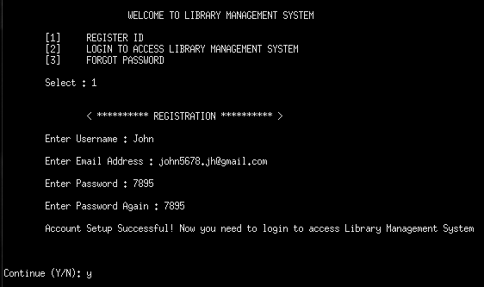

LOGGING IN TO SYSTEM

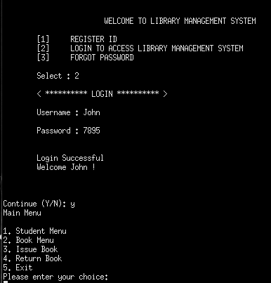

ENTERING TO SYSTEM

Student Entery into the system and display of records

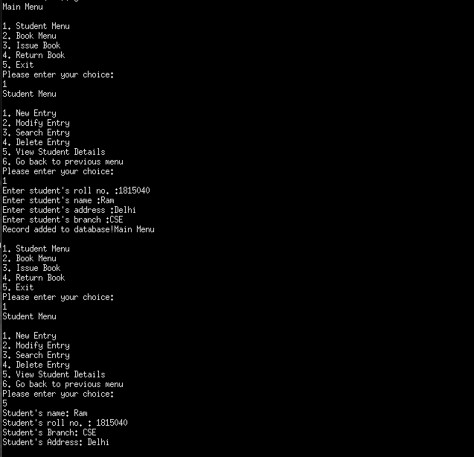
BOOK DETAILS ENTRY

Issue a Book

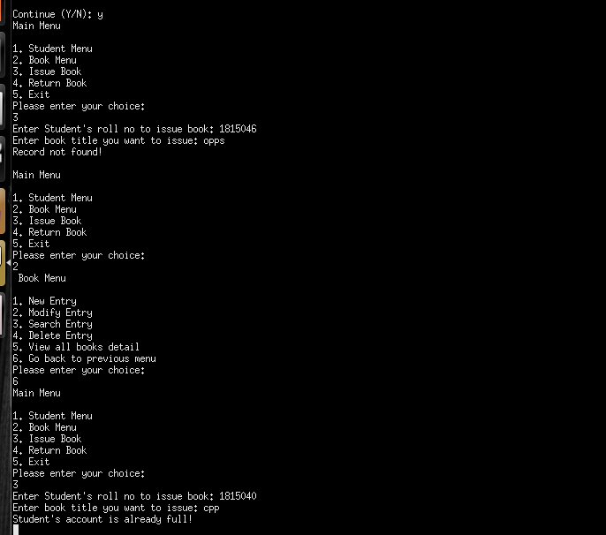

Returning a Book

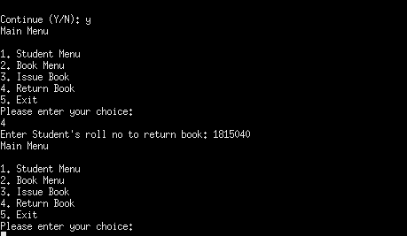

Modify Entry
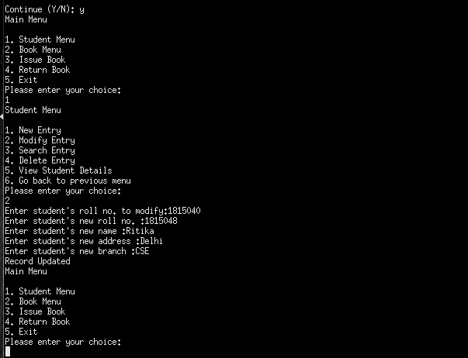

Search for Entry

Deleting the Entry

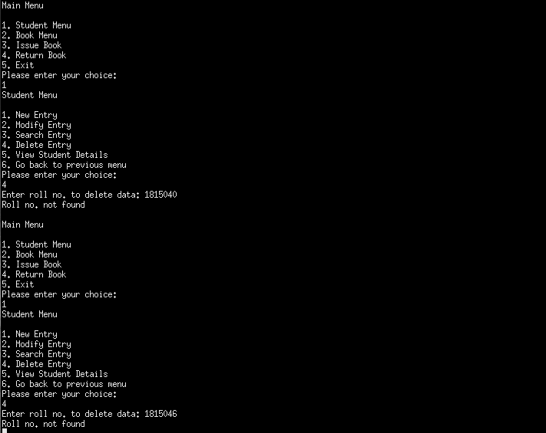

View Student Details

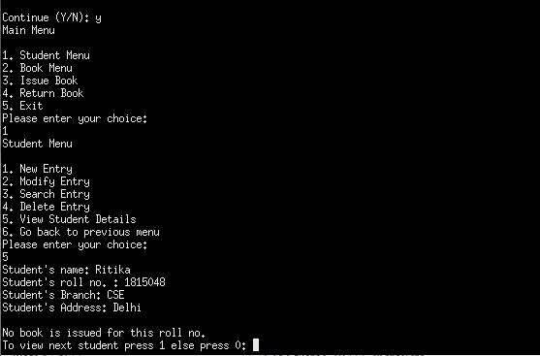

View Book Details

